NMAP HOST DISCOVERY USING ARP SCAN AND TCP/UDP/ICMP PING SCAN
EXPT NO: 7
INTRODUCTION
Discovering live hosts is the first step in network enumeration. Different techniques are useful in different situations: an ARP scan identifies machines on the same Ethernet/LAN by asking “who has this IP?”; an ICMP (ping) scan probes hosts by sending Echo Requests and waiting for replies; and capturing traffic with tcpdump lets you inspect the actual probe and reply packets for troubleshooting and verification. Combining these methods produces a more complete view because some hosts block ICMP or TCP probes but still respond to ARP, while packet capture reveals the raw traffic so you can see what was actually sent and received.
AIM
- Use ARP scanning to detect active hosts on the local subnet.
- Use ICMP (ping) scanning to find hosts that answer Echo Requests.
- Use tcpdump to capture and examine probe and reply packets for verification.
- Compare scan results and explain why a host might appear in one scan but not in another.

TASKS
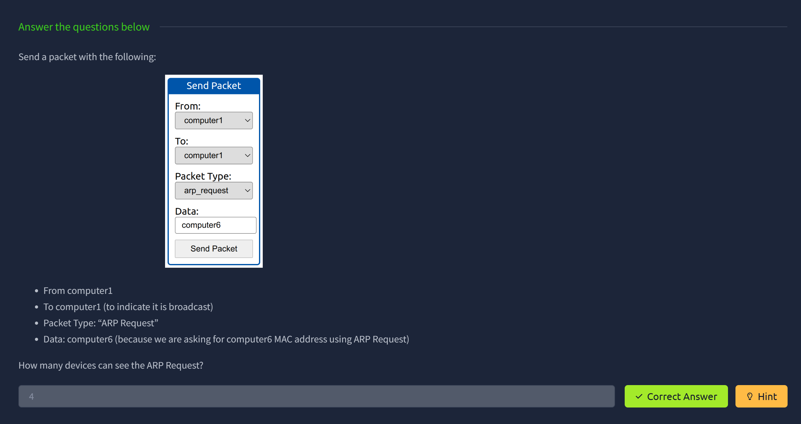
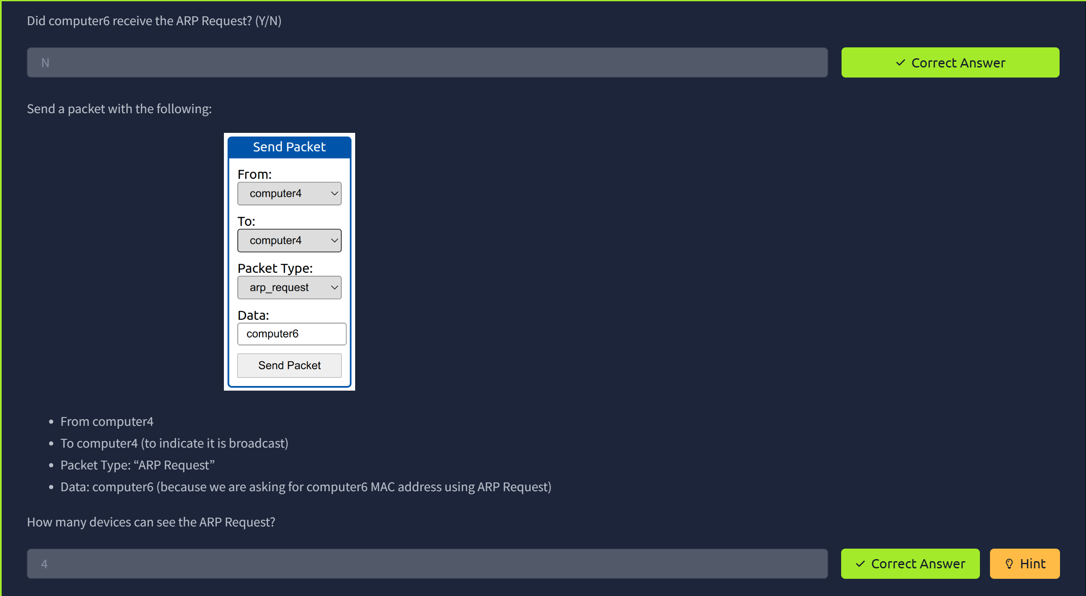
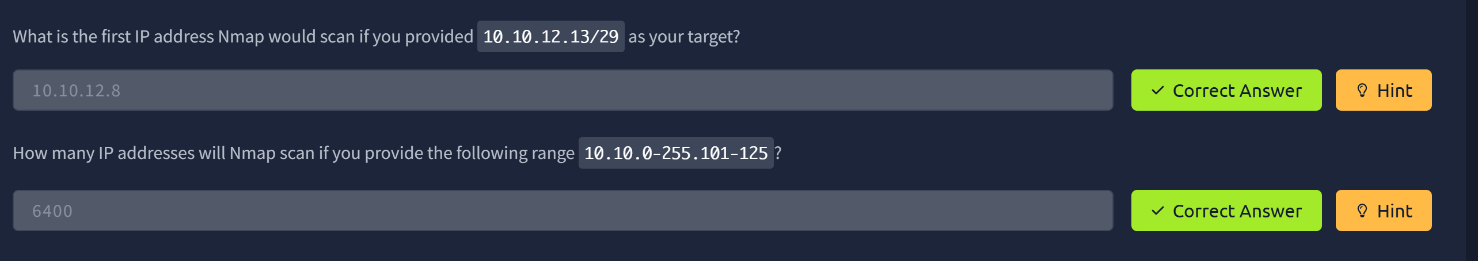
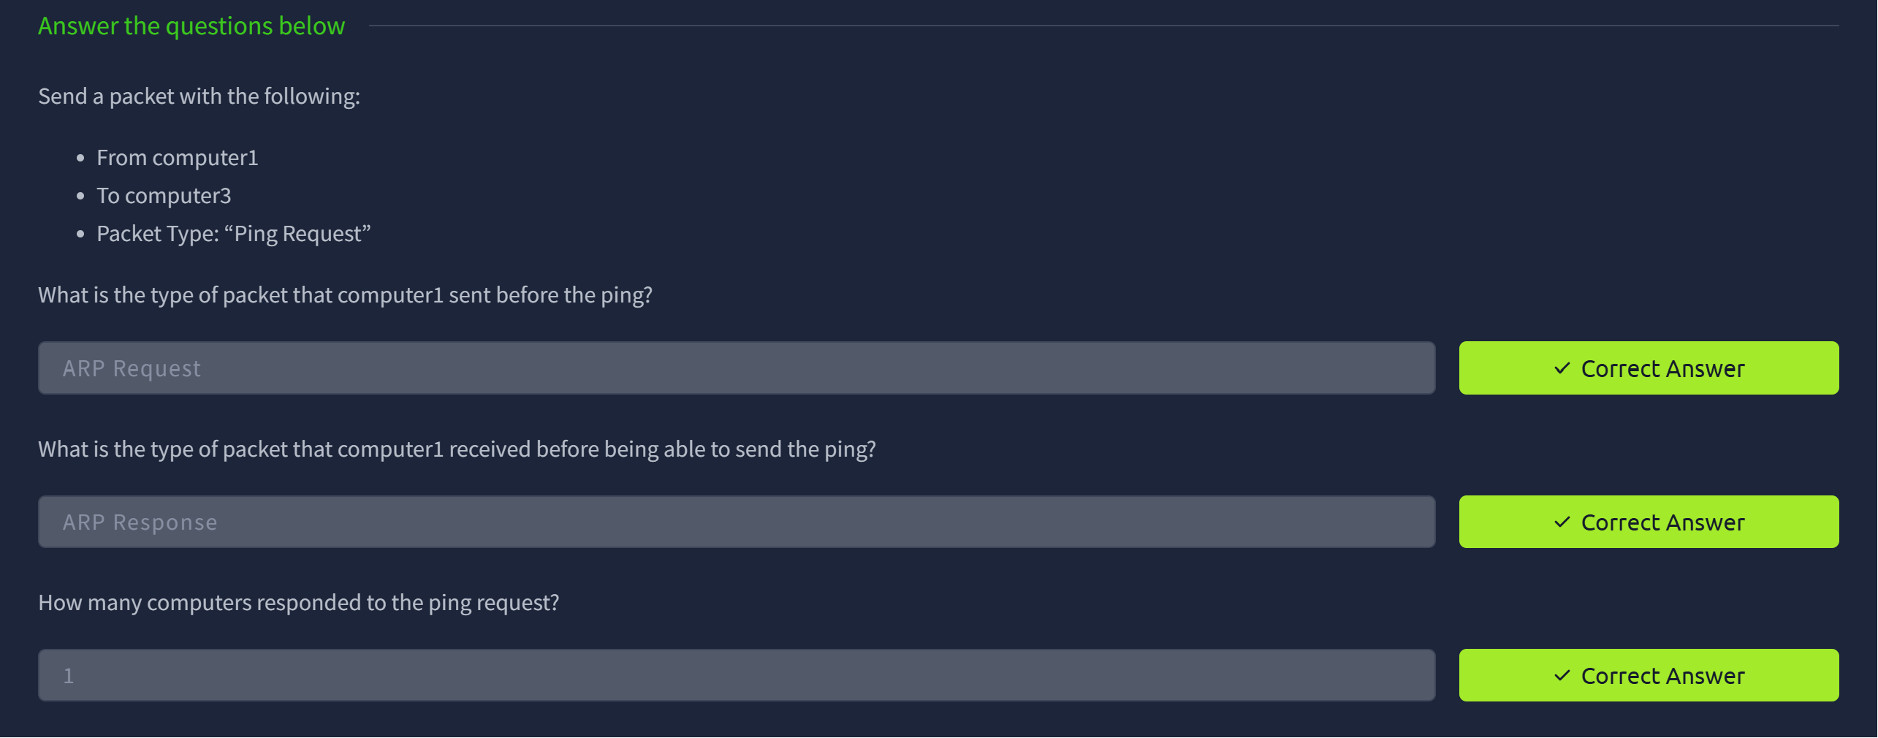
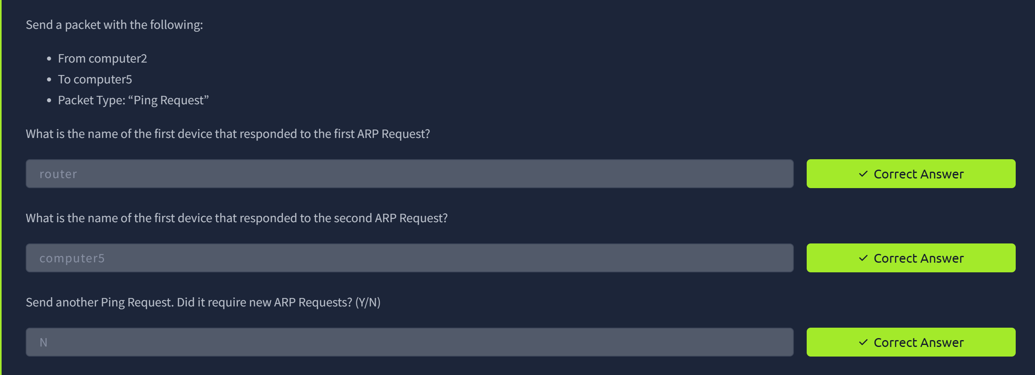
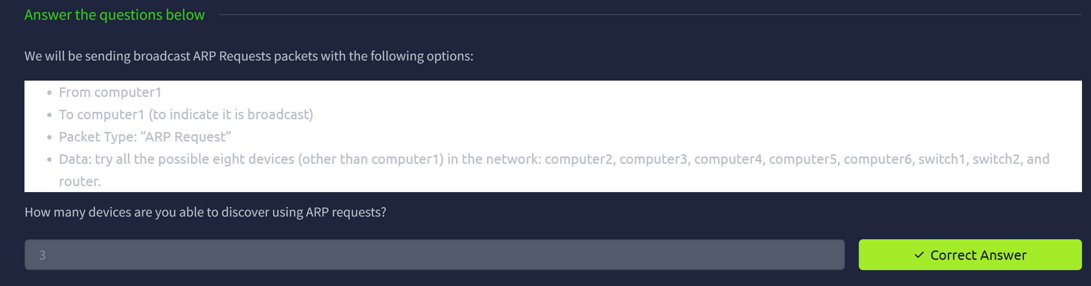
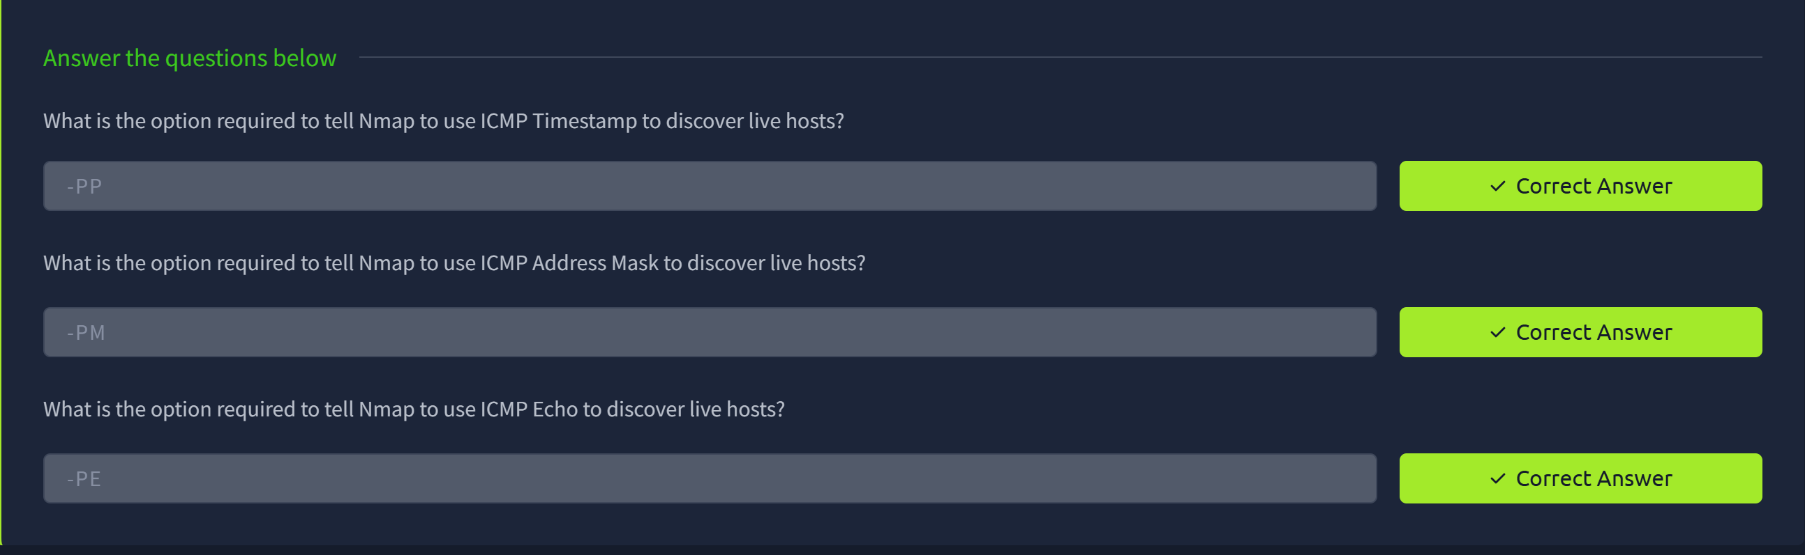
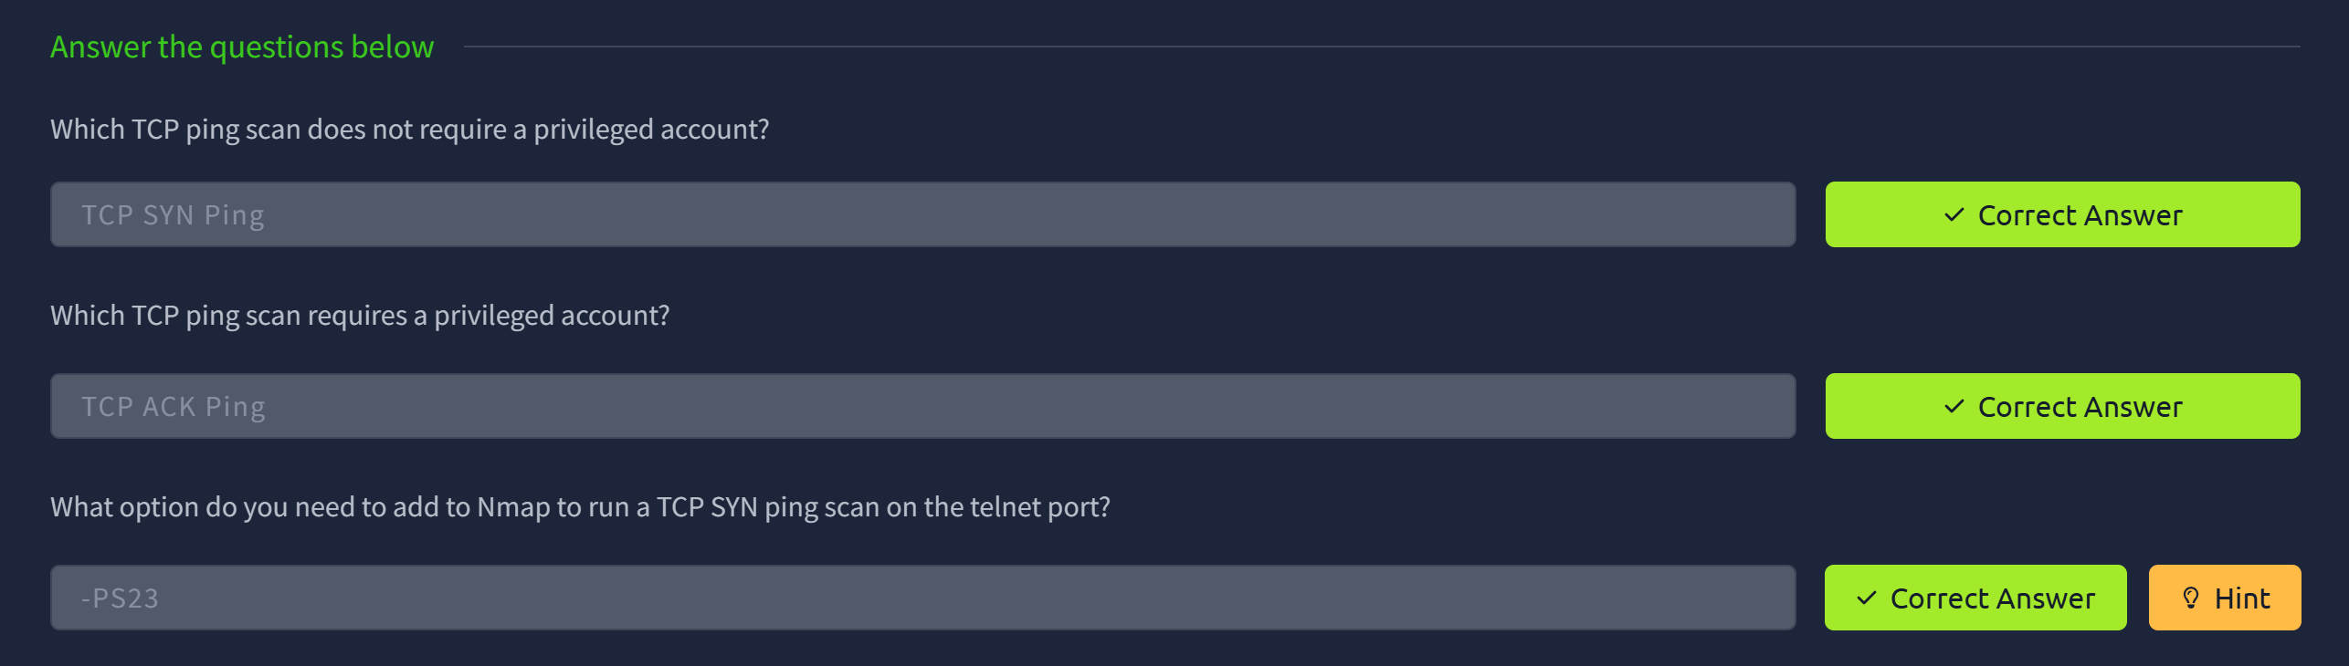
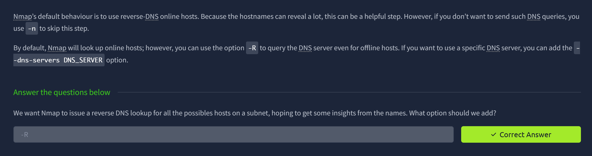

RESULT:
Ran an ARP scan on the local network (e.g. arp-scan or nmap -PR) and noted responsive IPs/MACs.
Performed an ICMP ping-scan (e.g. nmap -PE or fping) and recorded which hosts replied.
Started tcpdump during the ping scan to capture ICMP Echo Requests/Replies (and ARP requests/replies) for later inspection.
Performed an ICMP ping-scan (e.g. nmap -PE or fping) and recorded which hosts replied.

